Card Spoofer

Mark Nakamae

Cal Poly SLO

May 2020

**Behavior Description**

My project is a card emulator that sends a card’s magnetic strip (1st and 2nd tracks only) as a string through the UART to the MSP432. The MSP432 then generates electrical outputs that drive an optoisolator which in turn drives our inductor. Magnetic stripes are read through the changes in the surrounding magnetic field around the card reader. The voltages output from the MSP432 induced changes in the magnetic field near the card reader, which effectively tricks the card reader into scanning a “card”. As a result, the card reader will read the information sent from our inductor and write it to a text document.

**System Specification**

|  |  |  |  |
| --- | --- | --- | --- |
| **Power Supply Voltage** | **Clock Frequency** | **Size of keypad**  **(cm)** | **Size of MSP432**  **(cm)** |
| 3.3 V | 3 MHz | 6.6 x 7.6 | 5.7 x 9.2 |
| **Size of inductor**  **(cm)** | **Number of turns on inductor** | **Response time of keypad** | **Max Current through optoisolator** |
| 9.75 x 1 | ~ 300 | 1 second | 25mA |

Table 1: System specifications for each individual component

**System Architecture**

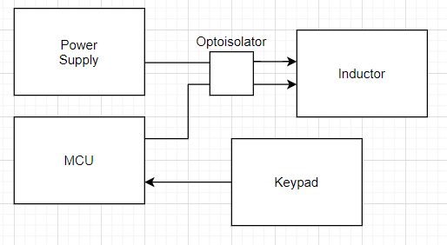

**Figure 1, Overall System Architecture:** The MSP is used to drive the optoisolator when it is in spoof mode. Since the optoisolator is a 2 gate package, we use to run currents in both directions in order to induce the magnetic fields needed to fool the card reader. When it is in read mode, it polls the UART connection to get a new card into its memory.

**System Schematic**

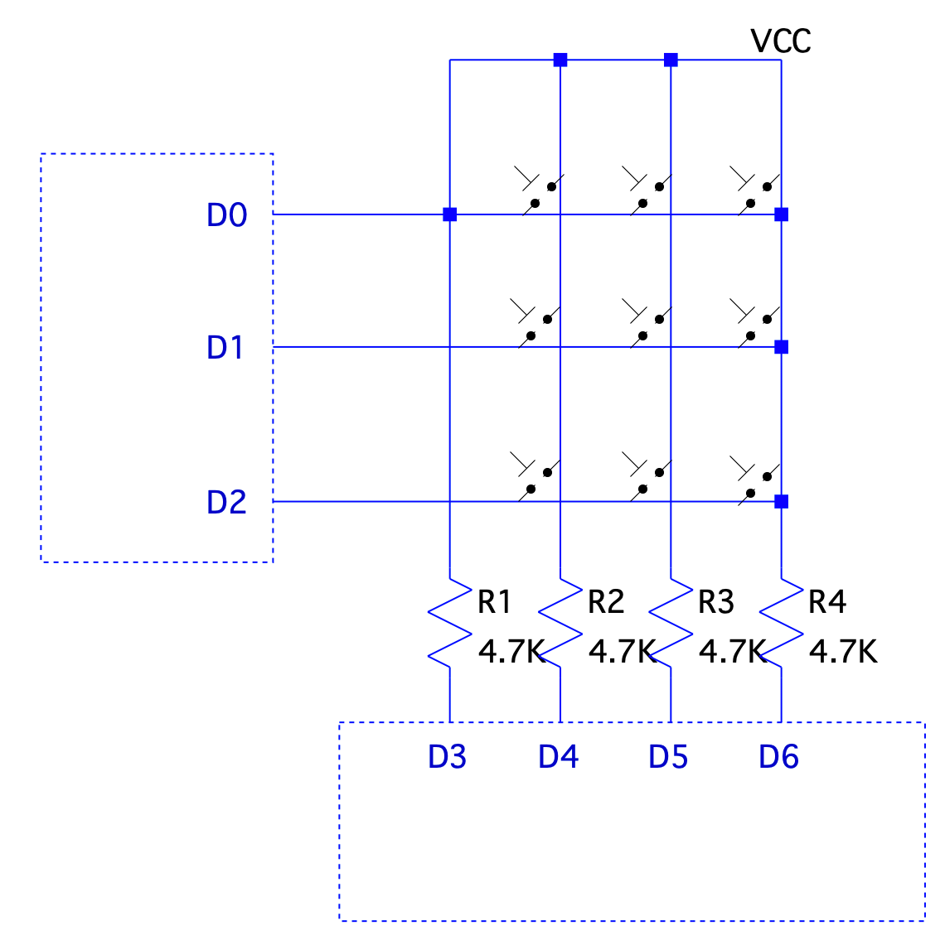

**Figure 2, Low level schematic of how the keypad interfaces with the MSP432**

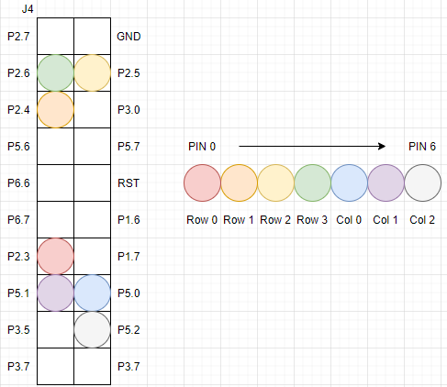

**Figure 3, Keypad Pinnings**: This diagram labels the pins connecting the keypad to the MSP432P401R board. Pin 0 on the keypad corresponds to row 0, and pin 6 corresponds to column 2. Note that J2 and J4 on the board is used for all GPIO related to the keypad.

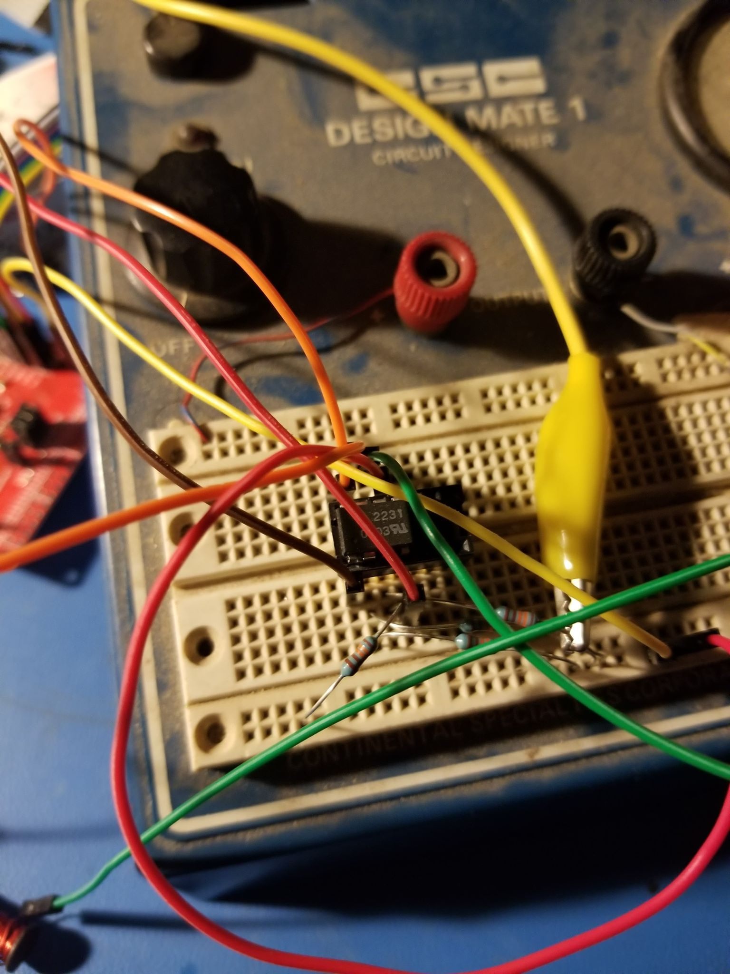

**Figure 4, Inductor Setup:** This inductor is driven by an optoisolator and power supply to increase the current inducing the magnetic field. The inductor was created by wrapping magnetic coil wire around a flattened nail. It’s also important to note here that a stronger inductor is needed to read tracks 2 and 3, so a H-bridge or more powerful optoisolator would be needed for this change.

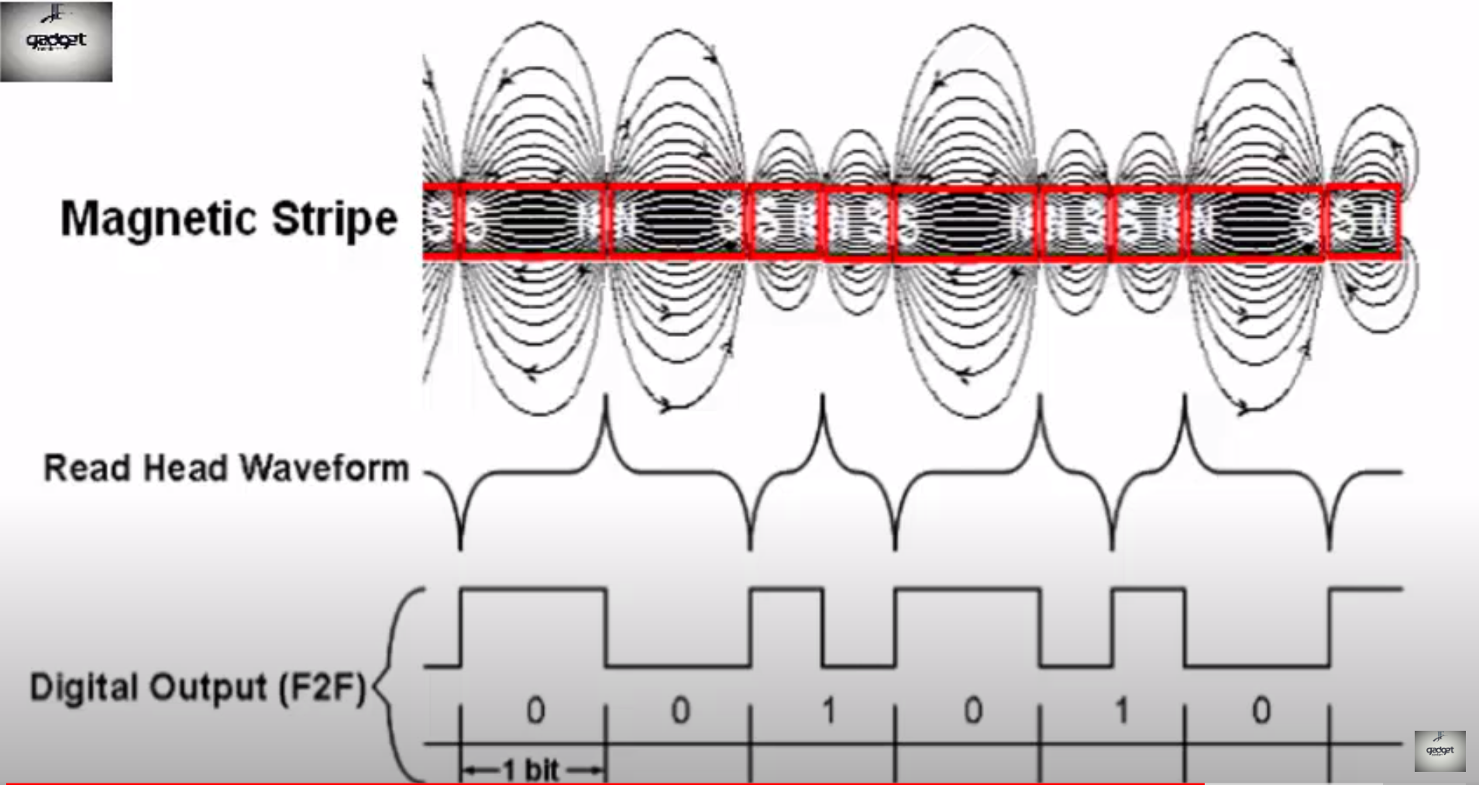

**Figure 5, Magstripe Readings:** Magnetic stripes are scanned by card readers by looking for changes in the surrounding magnetic field. 0’s are read when the directional bit flips only once, and 1’s are read when the directional bit flips twice.

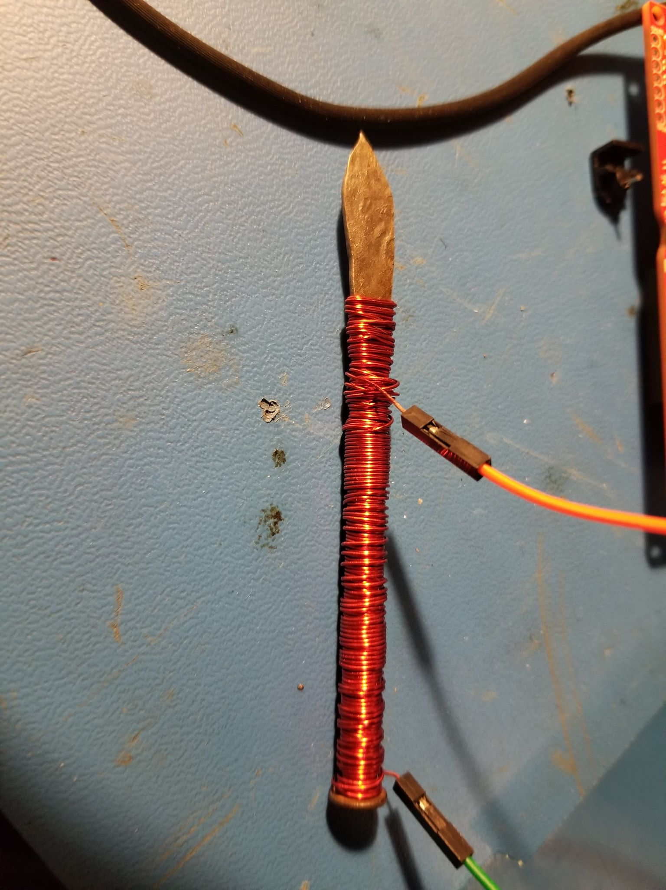

**Figure 6, Inductor Used:** This is the inductor used in the circuits above. It was made by flattening a nail, and wrapping magnetic coil wire around many times. The flattened head would then be stuck inside the card reader, and would cause a change in the magnetic field as induced by the MSP432. There are approximately 300 turns on this inductor.

**Software Architecture**

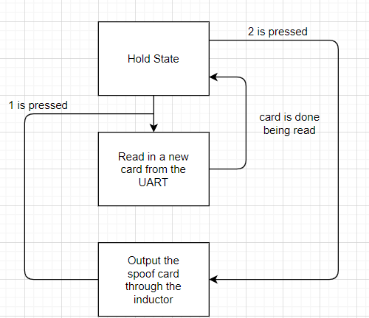

**Figure 7, Logic Flowchart:** This diagram shows the process flow of the device. Each condition for a state to move onto the next state is listed next to each arrow. Note that the device constantly outputs the spoofed card, and does not change its state until a 1 is pressed.

**Bill of Materials**

|  |  |  |  |  |  |  |
| --- | --- | --- | --- | --- | --- | --- |
| **ITEM NUMBER** | **PART NUMBER** | **ITEM** | **SUPPLIER** | **QUANTITY** | **PRICE EACH** | **PRICE EXTENDED** |
| 1 | 296-39653-ND | LaunchPad MSP432P401R Board | Texas Instruments | 1 | $23.59 | $23.59 |
| 2 | 1568-1511-ND | Jumper Wire M/F 6” 20 Pieces | SparkFun Electronics | 1 | $1.95 | $1.95 |
| 3 | 1528-1136-ND | Switch Keypad 12 Key Non-ILLUM | Adafruit Industries LLC | 1 | $3.95 | $3.95 |
| 4 | MSR90 | USB Swipe Magnetic Credit Card Reader | Deftun | 1 | $15.99 | $15.99 |
| 5 | EL-CP-003 | 830 Point Solderless Breadboard 3PCS | ELEGOO | 1 | $8.99 | $8.99 |
| 6 | ECW22AWG025LBG | 22 AWG Magnet Wire - Enameled Copper Wire | BNTECHGO-US | 1 | $6.98 | $6.98 |
| 7 | HCPL-2231 | Logic Gate Optocoupler | AVAGO TECHNOLOGIES | 1 | $9.81 | $9.81 |
| TOTAL | | | | | | **$71.26** |

**Table 2, Cost of Project:** This table shows the components used, as well as their prices and part numbers. Additionally, a nail was used for the inductor specified above, but any material that can hold a magnetic field can be used instead.

**Ethical Implications**

**Societal**: Obviously, a card spoofer could be disastrous in the wrong hands. The ability to spoof anyone’s information leads to massive security issues. As such, this device was a great learning experience to understand how magnetic stripes work, but have a fairly limited ethical usage. For this reason, the integrity of this device fully depends on the user; with great power comes great responsibility.

**Moral:** As stated above, a card spoofer can be dangerous. However, it could be useful if one didn’t want to carry around a card. For the most part, this device should never be used by the general populous, but it was fascinating to be able to create this tool. The applications of this beyond learning however, are extremely limited and mostly fall into the shady category. It is important to understand how this works in order to help create ways to stop would-be attackers such as ourselves.

**Educational:** The main intent of this project was to teach myself how card readers work and how to emulate a card going through. Additionally, learning how to manipulate these tracks should be of concern, especially since people’s information, money and other data are stored on these cards. I also got interested in learning how to possibly encrypt cards and add an extra layer of security to prevent hackers from easily taking people’s data. Like the spiderman quote “with great powers comes great responsibility” and this was a eye opening for me to see potential dangers of my project while having fun in a controlled environment.

**Conclusion**

To summarize, my system successfully output the first track of a card’s magstripe. Although I initially aimed to transmit more than just one track, I was limited by the hardware available to me. Given a stronger inductor, I would have also been able to transmit tracks 2 and 3. For this reason, Irecommend using transistors to increase the current through the inductor, which would create the required stronger magnet.

Additionally, I spent most of the time for the project reading how data from magstripes is both read and transmitted. Put simply, data is sent when the card induces a change in the magnetic field surrounding the card reader. One’s change the field twice and zero’s change the field once. Moreover, padding zeros and start/end sentinels are needed to differentiate different tracks from one another with each having a unique start identifier.

Overall, this project took a lot of time and effort debugging my hardware, rather than my code, but was very rewarding to finally see it working properly. I’ve learned a great deal as to how magnetic stripes work from the many reference manuals I found. I also learned that it is important to have the right components to make your product work optimally.

**Appendices**

Code:

delay.c

/*

* delay.c

*

* Created on: Apr 19, 2020

* Author: nakamae

*/

#include "msp.h"

#include "delay.h"

#define DELAY100MS 300000u // DELAY * 1 mS assuming 3 MHz clock

#define PORT_MCLK_OUT (P4)

#define BITM_MCLK_OUT (BIT3)

#define DELAY100MS 300000u // DELAY * 1 mS assuming 3 MHz clock

#define PORT_MCLK_OUT (P4)

#define BITM_MCLK_OUT (BIT3)

void set_DCO(int val)

{

/* Setting up Master CLK based on freq_sel */

CS->KEY = CS_KEY_VAL; // unlocks CS

CS->CTL0 = val;

CS->CTL1 = *0b011*;

CS->KEY = 0; // locks CS

}

void delay_us(int us)

{

int count, freq = CS->CTL0;

/* tuned for 40ms */

if (freq == FREQ_1_5MHz)

{

count = us / 7;

}

/* tuned for 40us */

else if (freq == FREQ_3MHz)

{

count = us / 6;

}

/* tuned for 40ms */

else if (freq == FREQ_6MHz)

{

count = (us * 10) / 18;

}

/* tuned for 40us */

else if (freq == FREQ_12MHz)

{

count = us;

}

/* tuned for 40ms */

else if (freq == FREQ_24MHz)

{

count = (us * 100) / 46;

}

else if (freq == FREQ_48MHz)

{

count = (us * 48) / 10;

}

while( count > 0)

{

__delay_cycles(1);

count-=1;

}

}

delay.h

/*

* delay.h

*

* Created on: Apr 19, 2020

* Author: nakamae

*/

#ifndef DELAY_H_

#define DELAY_H_

#define FREQ_1_5MHz CS_CTL0_DCORSEL_0

#define FREQ_3MHz CS_CTL0_DCORSEL_1

#define FREQ_6MHz CS_CTL0_DCORSEL_2

#define FREQ_12MHz CS_CTL0_DCORSEL_3

#define FREQ_24MHz CS_CTL0_DCORSEL_4

#define FREQ_48MHz CS_CTL0_DCORSEL_5

void delay_us(int us);

void set_DCO(int val);

#endif /* DELAY_H_ */

keypad.c

#include "keypad.h"

#include "msp.h"

#include "delay.h"

void keypad_init(void) {

P2->SEL0 &= ~(ROW_0 | ROW_1 | ROW_2 | ROW_3); // Sets P5.0-P5.2 to GPIO (COL)

P2->SEL1 &= ~(ROW_0 | ROW_1 | ROW_2 | ROW_3);

P2->DIR &= ~(ROW_0 | ROW_1 | ROW_2 | ROW_3); // Sets inputs with a pulldown resistor

P2->REN |= (ROW_0 | ROW_1 | ROW_2 | ROW_3);

P2->OUT &= ~(ROW_0 | ROW_1 | ROW_2 | ROW_3);

P5->SEL0 &= ~(COL_0 | COL_1 | COL_2); // Sets P2.3-P2.6 to GPIO (ROW)

P5->SEL1 &= ~(COL_0 | COL_1 | COL_2);

P5->DIR |= (COL_0 | COL_1 | COL_2); // Sets P2.3-P2.6 to outputs

}

/*

* This is a non-blocking function to read the keypad.

* If a key is pressed, it returns that key value 0-9. * is 10, # is 12

* If no key is pressed, it returns 0xFF

* Port 4.0 - 4.3 are used as inputs and connected to the rows. Pull-down

* resistors are enabled so when no key is pressed, these pins are pulled low

*

* The Port 4.4 - 4.6 are used as outputs that drives the keypad columns.

* First all columns are driven high and the input pins are read. If no key is

* pressed, they will read zero because of the pull-down resistors. If no key

* is pressed, return 0xFF. If the value is non-zero, determine which key is

* being pressed.

* To determine which key is being pressed, the program proceeds to drive one

* column high at a time and read the input pins (rows). Knowing which row is

* high and which column is active, the program can decide which key is pressed

*

*/

uint8_t keypad_Getkey(void) {

uint8_t row, col, key;

/* check to see any key pressed */

P5->OUT |= (COL_0 | COL_1 | COL_2); // drive all column pins high

_delay_cycles(25); // wait for signals to settle

row = P2->IN & (ROW_0 | ROW_1 | ROW_2 | ROW_3); // read all row pins

if (row == 0) // if all rows are low, no key pressed

return 0xFF;

/* If a key is pressed, it gets here to find out which key.

* It activates one column at a time and reads the input to see

* which row is active. */

for (col = 0; col < 3; col++) {

// zero cols

P5->OUT &= ~(COL_0 | COL_1 | COL_2);

// shift a 1 into the correct column depending on which to turn on

P5->OUT |= (COL_0 << col);

_delay_cycles(25); // wait for signals to settle

row = P2->IN & (ROW_0 | ROW_1 | ROW_2 | ROW_3); // mask only the row pins

if (row != 0) break; // if the input is non-zero, key detected

}

P5->OUT &= ~(COL_0 | COL_1 | COL_2); // drive all columns low

if (col == 3) return 0xFF; // if we get here, no key was detected

// rows are read in binary, so powers of 2 (1,2,4,8)

if (row == 8) row = 1;

if (row == 16) row = 2;

if (row == 32) row = 3;

if (row == 64) row = 4;

/*******************************************************************

* IF MULTIPLE KEYS IN A COLUMN ARE PRESSED THIS WILL BE

INCORRECT *

*******************************************************************/

// calculate the key value based on the row and columns where detected

if (col == 0) key = row*3 - 2;

if (col == 1) key = row*3 - 1;

if (col == 2) key = row*3;

return key;

}

keypad.h

/*

* keypad.h

*

* Created on: Apr 26, 2020

* Author: nakamae

*/

#ifndef KEYPAD_H_

#define KEYPAD_H_

#include <stdint.h>

#define COL_0 BIT0

#define COL_1 BIT1

#define COL_2 BIT2

#define ROW_0 BIT3

#define ROW_1 BIT4

#define ROW_2 BIT5

#define ROW_3 BIT6

void keypad_init(void);

uint8_t keypad_Getkey(void);

#endif /* KEYPAD_H_ */

reader.c

/*

* reader.c

*

* Created on: Jun 7, 2020

* Author: nakamae

*/

#include "msp.h"

#include "delay.h"

#include "reader.h"

// direction of the magnetic field

uint8_t direction=0;

// the second track look up table

uint8_t SECOND[16]= { *0b00001*,/* 0, (0H) Data*/

*0b10000*, /* 1 (1H) */

*0b01000*,/* 2 (2H) " */

*0b11001*, /* 3 (3H) "*/

*0b00100*, /* 4 (4H) "*/

*0b10101*, /* 5 (5H) "*/

*0b01101*, /* 6 (6H) "*/

*0b11100*, /* 7 (7H) "*/

*0b00010*, /* 8 (8H) "*/

*0b10011*, /* 9 (9H) "*/

*0b01011*, /* : (AH) Control*/

*0b11010*, /* ; (BH) Start Sentinel*/

*0b00111*, /* < (CH) Control*/

*0b10110*, /* = (DH) Field Separator*/

*0b01110*, /* > (EH) Control*/

*0b11111* /* ? (FH) End Sentinel*/

};

// the first track look up table

uint8_t TABLE[64] = { *0b0000001*, /* space (0H) */

*0b1000000*, /* ! (1H) */

*0b0100000*, /* (2H) */

*0b1100001*, /* # (3H) */

*0b0010000*, /* $ (4H) */

*0b1010001*, /* % (5H) SS*/

*0b0110001*, /* & (6H) */

*0b1110000*, /* ' (7H) */

*0b0001000*, /* ( (8H) */

*0b1001001*, /* ) (9H) */

*0b0101001*, /* * (AH) */

*0b1101000*, /* + (BH) */

*0b0011001*, /* , (CH) */

*0b1011000*, /* - (DH) */

*0b0111000*, /* . (EH) */

*0b1111001*, /* / (FH) */

*0b0000100*, /* 0 (10H) */

*0b1000101*, /* 1 (11H) */

*0b0100101*, /* 2 (12H) */

*0b1100100*, /* 3 (13H) */

*0b0010101*, /* 4 (14H) */

*0b1010100*, /* 5 (15H) */

*0b0110100*, /* 6 (16H) */

*0b1110101*, /* 7 (17H) */

*0b0001101*, /* 8 (18H) */

*0b1001100*, /* 9 (19H) */

*0b0101100*, /* : (1AH) */

*0b1101101*, /* ; (1BH) */

*0b0011100*, /* < (1CH) */

*0b1011101*, /* = (1DH) */

*0b0111101*, /* > (1EH) */

*0b1111100*, /* ? (1FH) ES*/

*0b0000010*, /* @ (20H) */

*0b1000011*, /* A (21H) */

*0b0100011*, /* B (22H) */

*0b1100010*, /* C (23H) */

*0b0010011*, /* D (24H) */

*0b1010010*, /* E (25H) */

*0b0110010*, /* F (26H) */

*0b1110011*, /* G (27H) */

*0b0001011*, /* H (28H) */

*0b1001010*, /* I (29H) */

*0b0101010*, /* J (2AH) */

*0b1101011*, /* K (2BH) */

*0b0011010*, /* L (2CH) */

*0b1011011*, /* M (2DH) */

*0b0111011*, /* N (2EH) */

*0b1111010*, /* O (2FH) */

*0b0000111*, /* P (30H) */

*0b1000110*, /* Q (31H) */

*0b0100110*, /* R (32H) */

*0b1100111*, /* S (33H) */

*0b0010110*, /* T (34H) */

*0b1010111*, /* U (35H) */

*0b0110111*, /* V (36H) */

*0b1110110*, /* W (37H) */

*0b0001110*, /* X (38H) */

*0b1001111*, /* Y (39H) */

*0b0101111*, /* Z (3AH) */

*0b1101110*, /* [ (3BH) */

*0b0011111*, /* \ (3DH) */

*0b1011110*, /* ] (3EH) */

*0b0111110*, /* ^ (3FH) */

*0b1111111* /* _ (40H) */

};

// outputs a specified character in the magstripe reader format for the first track

void outputFunc(uint8_t character)

{

int i;

for (i = *0b1000000*; i > *0b0000000*; i = i >> 1)

{

if (character & i)

{

send(1);

}

else

{

send(0);

}

}

}

// sends a change in magnetic field to the output pins

void send(uint8_t bit)

{

direction ^= 1; // flip direction

if (direction)

{

P3->OUT &= ~(BIT6);

P3->OUT |= BIT7;

}

else

{

P3->OUT &= ~(BIT7);

P3->OUT |= BIT6;

}

delay_us(200);

if (bit) // if bit to send is a 1 flip the output bit a second time

{

direction ^= 1; // flip direction

if (direction)

{

P3->OUT &= ~(BIT6);

P3->OUT |= BIT7;

}

else

{

P3->OUT &= ~(BIT7);

P3->OUT |= BIT6;

}

}

delay_us(200);

}

// outputs a specified character in the magstripe reader format for second track

void output_sec(uint8_t character)

{

int i;

for (i = *0b10000*; i > *0b0*; i = i >> 1) // send a 1 or 0 based on ascii tables above

{

if (character & i)

{

send(1);

}

else

{

send(0);

}

}

}

reader.h

/*

* reader.h

*

* Created on: Jun 7, 2020

* Author: nakamae

*/

#ifndef READER_H_

#define READER_H_

#define ASCII_OFFSET_AGAIN 32

extern uint8_t SECOND[];

extern uint8_t TABLE[];

void outputFunc(uint8_t);

void output_sec(uint8_t character);

void send(uint8_t );

#endif /* READER_H_ */

uart.c

#include "msp.h"

#include "uart.h"

/* reads in a character from the UART cable buffer */

uint8_t uart_getChar(void)

{

while(!(EUSCI_A0->IFG & EUSCI_A_IFG_RXIFG)) { }

return EUSCI_A0->RXBUF;

}

/* sends a character to the UART cable buffer */

void uart_transmitChar(uint8_t c)

{

while(!(EUSCI_A0->IFG & EUSCI_A_IFG_TXIFG)) { }

EUSCI_A0->TXBUF = c;

}

void UART0_init(void)

{

EUSCI_A0->CTLW0 |= EUSCI_B_CTLW0_SWRST; /* put in reset mode for config */

EUSCI_A0->MCTLW &= ~EUSCI_A_MCTLW_OS16; /* disable oversampling */

EUSCI_A0->CTLW0 = EUSCI_B_CTLW0_UCSSEL_2|EUSCI_B_CTLW0_SWRST; /* 1 stop bit, no parity, SMCLK, 8-bit data */

EUSCI_A0->BRW = 26; /* 3,000,000 / 115200 = 26 */

P1->SEL0 |= (BIT2|BIT3); /* P1.3, P1.2 for UART */

P1->SEL1 &= ~(BIT2|BIT3);

/* take UART out of reset mode */

EUSCI_A0->CTLW0 &= ~EUSCI_B_CTLW0_SWRST; }

void scale(uint16_t *data, uint8_t tmp)

{

(*data) *= 10;

(*data) += tmp;

}

uart.h

#ifndef UART_H_

#define UART_H_

#define ASCII_OFFSET 48

#define MAX_DAC 1023

#define MAX_BUF 5

uint8_t uart_getChar(void);

void uart_transmitChar(uint8_t);

void UART0_init(void);

void scale(uint16_t *, uint8_t);

#endif /* UART_H_ */

main.c

#include "msp.h"

#include "uart.h"

#include <string.h>

#include "reader.h"

#include "delay.h"

#include "stdio.h"

#include "keypad.h"

#define SPOOF 2

#define READ 1

#define HOLD 0

uint8_t state = HOLD;

// sets the state based on the keypressed

void readin(uint8_t key)

{

switch(key)

{

case 1:

state = READ;

break;

case 2:

state = SPOOF;

break;

default:

state = HOLD;

break;

}

}

/**

* main.c

*/

void main(void)

{

WDT_A->CTL = WDT_A_CTL_PW | WDT_A_CTL_HOLD; // stop watchdog timer

char card[512] = "%2015037409328^STUDENT?;6278561807527737?"; // buffer to hold

// card info

P3->DIR |= (BIT6 | BIT7); // Configure pin 3.6 and 3.7 as output

P3->SEL0 &= ~(BIT6|BIT7);

P3->SEL1 &= ~(BIT6 |BIT7);

P3->OUT = 0; // Set Pin 3.6 and 3.7 low

UART0_init(); // initialize the UART

keypad_init(); // initialize the keypad

int zero_ind = 0, ind = 0, first_track = 0, card_track = 0;

uint8_t lrc = 0, press;

char tmp;

while(1)

{

press = keypad_Getkey(); // get keypress

if (press !=0xFF)

{

readin(press);

delay_ms(750);

}

if (state == READ) // read the new card from the UART buffer

{

tmp = uart_getChar();

while((tmp != 0xD ))

{

card[ind] = tmp;

tmp = uart_getChar();

ind++;

}

card[ind] = '\0';

ind = 0;

state = HOLD;

}

else if(state==SPOOF)

{

// write first track

for (zero_ind = 0; zero_ind < 62; zero_ind ++)

{

send(0); // pad with zeros

}

lrc = 0;

for (card_track = 0; card[card_track] != ';' && card[card_track] !='\0';

card_track++) // end of first track or strlen

{

outputFunc(TABLE[(uint8_t) (card[card_track ] - ASCII_OFFSET_AGAIN)]);

lrc ^= TABLE[(uint8_t) (card[card_track ] - ASCII_OFFSET_AGAIN)];

}

outputFunc(lrc);

for (zero_ind = 0; zero_ind < 63+35; zero_ind ++)

{

send(0); // pad with zeros

}

for (zero_ind = 0; zero_ind < 22; zero_ind ++)

{

send(0); // pad with zeros

}

lrc = 0;

// write second track

for (; card[card_track ] !='\0'; card_track ++) // i < strlen(card)

{

output_sec(SECOND[(uint8_t) (card[card_track ] - 48)]);

lrc ^= SECOND[(uint8_t) (card[card_track ] - 48)];

}

output_sec(lrc);

for (zero_ind = 0; zero_ind < 61; zero_ind ++)

{

send(0); // pad with zeros

}

lrc = 0;

}

else

{

continue;

}

}

}

**References**

[MSP432 datasheet](http://www.ti.com/lit/ds/symlink/msp432p401r.pdf?ts=1588064064864)

[Magnetic Stripe Technical Manual](https://www.magtek.com/content/documentationfiles/d99875148.pdf?fbclid=IwAR2R-Qm1TV-nBL1MatDTwOF4RPks12RCYVZYJw8SMYsy4LNkbsaQkiUEtnA)

[How Magnetic Stripes Work](https://www.youtube.com/watch?v=jhGj-NzOlJ8&start=164)

[HCPL-2231 Datasheet](https://datasheet.octopart.com/HCPL-2231-Avago-datasheet-7624477.pdf)